SUPPLEMENTAL TABLES
Table S1. Summary of analyses and significant CpGs at a Bonferroni-corrected q<0.05.
 |  | Data version changes |  |  |  | Analytic version changes
Analysis details
 | Analytic approach | EWAS |  | SLCMA |  | SLCMA
 | Inference method | Ordinary least squares |  | Covariance test |  | Selective inference
 | Covariate adjustment | Standardª |  | Standardª |  | Standardª | FWL^{c}
 | Data version | Old | New | Old | New | New
Adversity hits^{d}
 | Abuse (sexual or physical) | 1 | 0 | 5 | 2 | 0 | 1
 | Financial stress | 0 | 0 | 14 | 11 | 0 | 0
 | Family instability | 0 | 0 | 4 | 14 | 0 | 4
 | Maternal psychopathology | 0 | 0 | 3 | 10 | 0 | 0
 | Neighborhood disadvantage | 0 | 0 | 7 | 1 | 0 | 0
 | One adult household | 0 | 0 | 6 | 3 | 0 | 0
 | Parental cruelty | 0 | 0 | 6 | 5 | 1 | 1
ª Covariate adjustment was performed using standard methods for linear regressions (note this is equivalent to the Frisch-Waugh-Lovell theorem adjustment described below).
^{b} The standard adjustment strategy for the SLCMA uses the residuals of the exposures regressed on the covariates, also known as “single residual” adjustment.
^{c} Frisch-Waugh-Lovell (FWL) theorem applied for covariate adjustment and socioeconomic position replaced with maternal education.
^{d} Number of associated CpGs at a p<1.13x10⁻⁷.

Table S2. Summary of analyses of prenatal smoking and significant CpGs at FDR<0.05 and Bonferroni-corrected q<0.05.
 |  | Data version changes |  |  |  |  |  | Analytic version changes
Analysis details
 | Analytic approach | EWAS |  |  | SLCMA |  |  | SLCMA
 | Inference method | Ordinary least squares |  |  | Covariance test |  |  | Selective inference
 | Covariate adjustment | Standardª |  |  | Standard^{b} |  |  | Standard^{b} | FWL^{c}
 | Data version | Old |  | New | Old |  | New | New
False discovery rate (FDR) <0.05 |  | 27 | 23 |  | 24 | 4576 |  | 0 | 13
Bonferroni-corrected q<0.05 |  | 15 | 14 |  | 6 | 43 |  | 0 | 6
ª Covariate adjustment was performed using standard methods for linear regressions (note this is equivalent to the Frisch-Waugh-Lovell theorem adjustment described below).
^{b} The standard adjustment strategy for the SLCMA uses the residuals of the exposures regressed on the covariates, also known as “single residual” adjustment.
^{c} Frisch-Waugh-Lovell (FWL) theorem applied for covariate adjustment and socioeconomic position replaced with maternal education.

SUPPLEMENTAL FIGURES

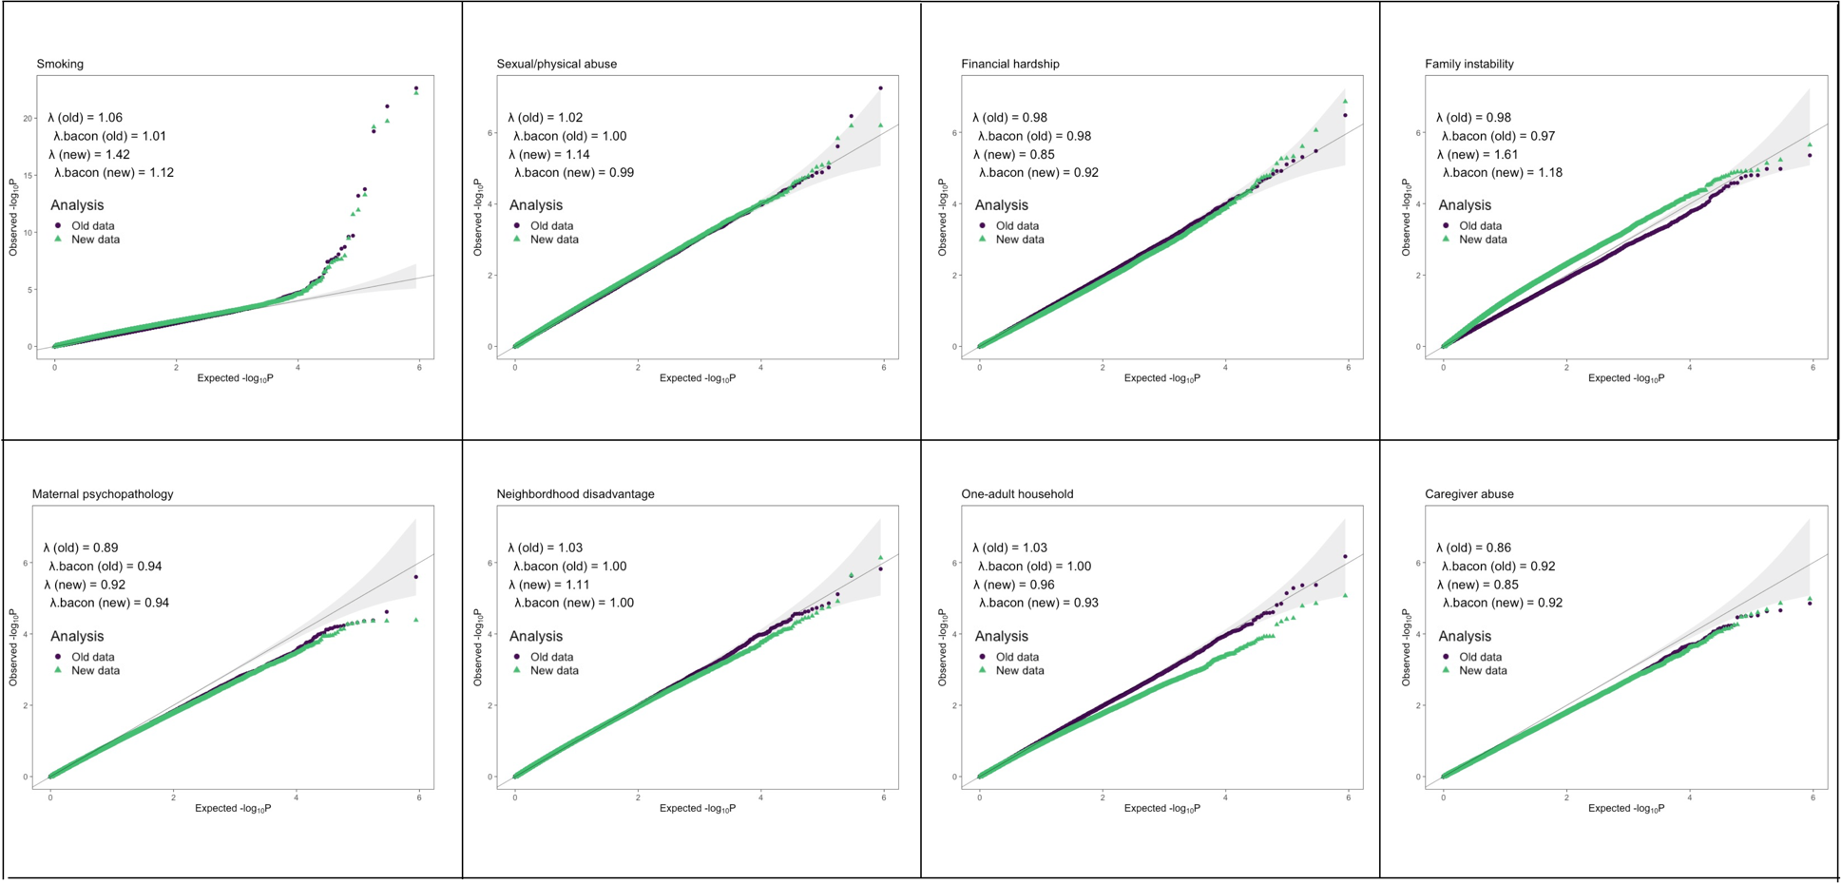
Figure S1. Quantile-quantile plots of the epigenome-wide association studies.
The distribution of expected versus observed p-values for each EWAS. Genomic inflation factors (λ) and bacon inflation estimates (λ.bacon) are shown for the analysis in the old and the new data versions. Overall, both the old and new data showed expected distribution, with the exception of exposure to maternal smoking during pregnancy, which showed larger inflation factors.

Figure S2. Quantile-quantile plots of the SLCMA analyses.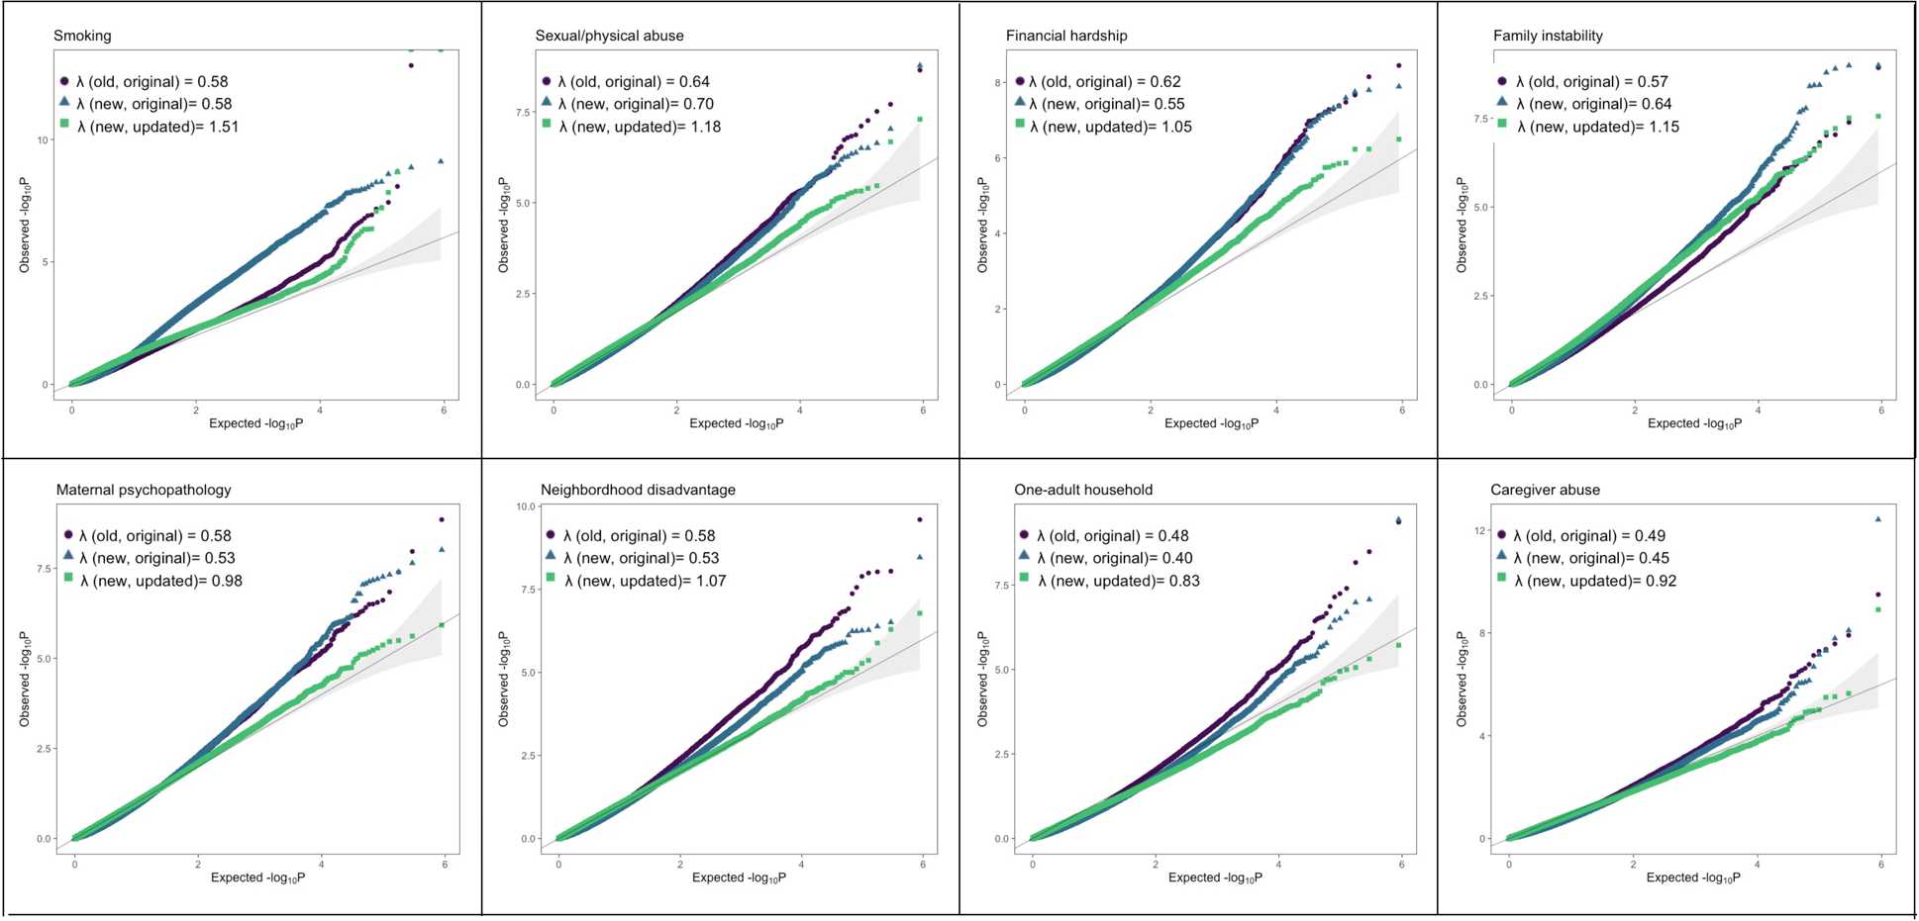
The distribution of expected versus observed p-values for each SLCMA analysis. Genomic inflation factors (λ) are shown for each analysis. Analyses were 1) old data with original analytic methods (old, original), 2) new data with original analytic methods (new, original), and 3) new data with updated analytic methods (new, updated). Overall, the new data and updated methods showed less inflation and more consistent p-value distributions.

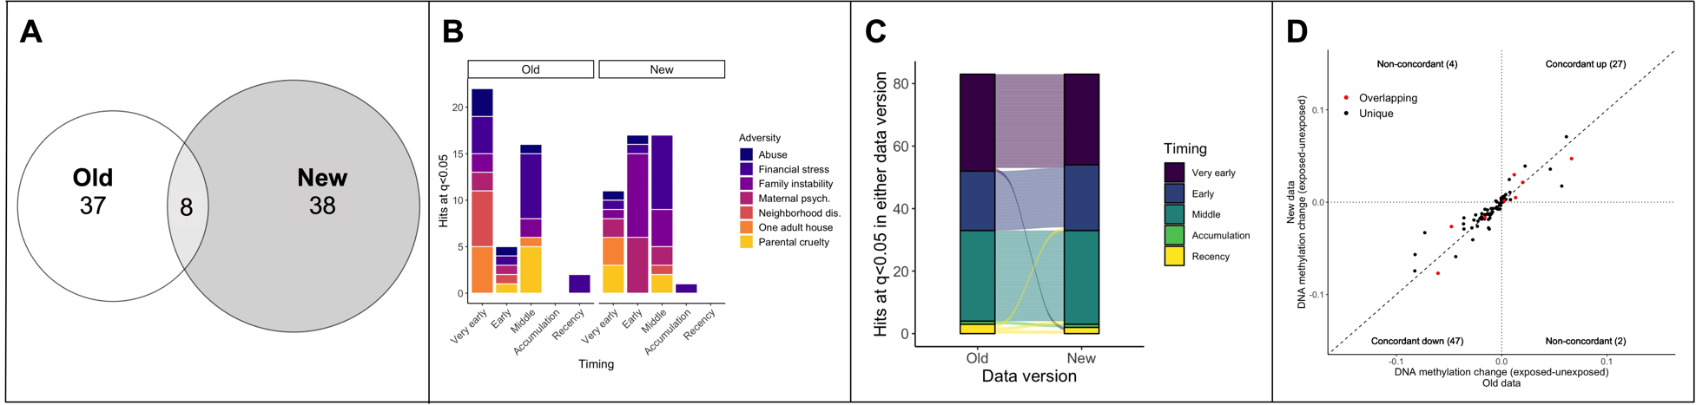
Figure S3. Bonferroni-corrected results from the SLCMA of adversity and differences between data versions.
A) Overlap of the hits at Bonferroni-corrected q<0.05 between the old and new data for all seven different SLCMA of childhood adversity.
B) Both the hypotheses selected most frequently, and the adversities identified as having the most hits varied between data versions with the SLCMA for CpGs significant at q<0.05.
C) The selected hypothesis from all top hits (shown in B) were generally consistent across data versions. Each line depicted corresponds to a specific CpG and shows whether its selected hypothesis differs between analyses.
D) The difference in DNAm values between exposed and unexposed participants across all top SLCMA hits from E was generally consistent between data versions, regardless of statistical significance (r=0.915). Only shown here are the CpGs associated with sensitive period hypotheses, as the difference between exposed and unexposed individuals was not calculated for the accumulation and recency hypotheses.
*Maternal psych = maternal psychopathology; Neighborhood dis = neighborhood disadvantage.

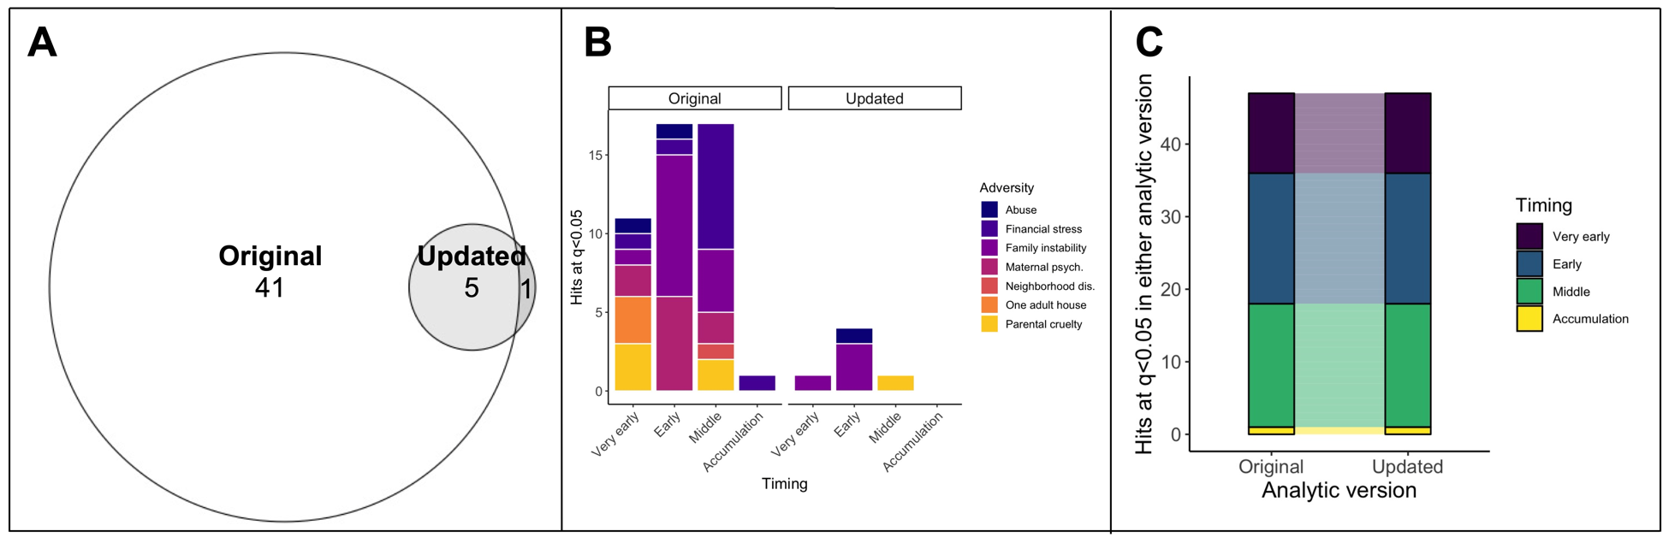
Figure S4. Bonferroni-corrected results from the analytic version differences in SLCMA of adversity.
A) Overlap of the hits at Bonferroni-corrected q<0.05 for all seven different SLCMA of adversity between the standard and updated analytic versions (analyses performed with the new data).
B) The pattern of hypotheses selected were similar across both analytic versions, though not all adversities had statistically significant associations in the updated analytic version.
C) The hypothesis selected across all significant CpGs from A was consistent across analytic versions.
*Maternal psych = maternal psychopathology; Neighborhood dis = neighborhood disadvantage.

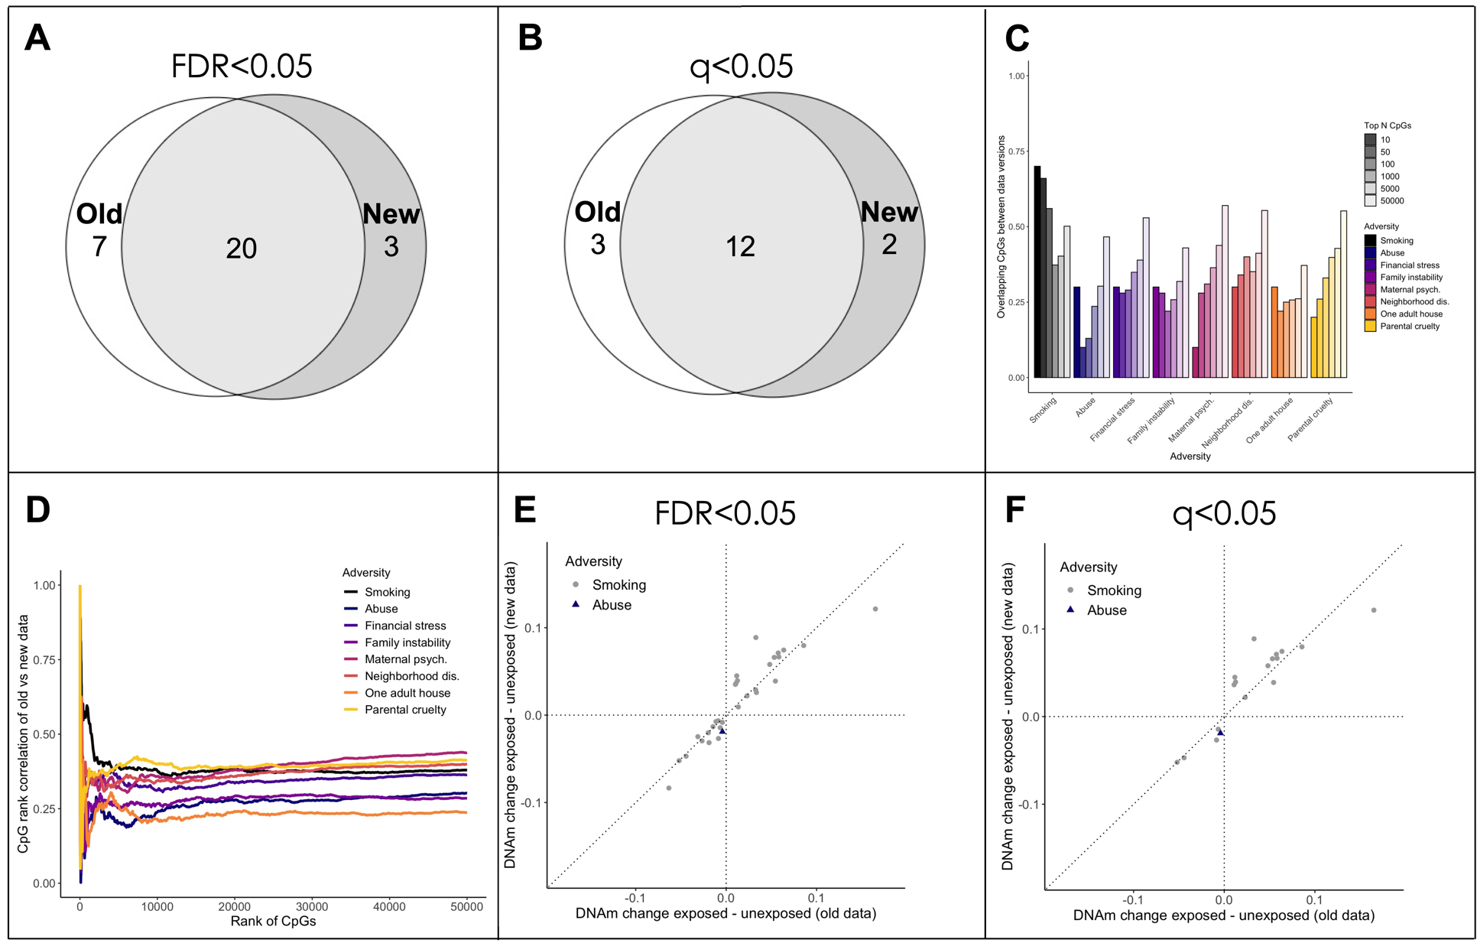
Figure S5. Results from the EWAS of prenatal smoking and postnatal adversity.
A) Overlap of the hits at FDR<0.05 for the EWAS of prenatal smoking exposure between the old and new data.
B) Overlap of the hits at a Bonferroni-corrected q<0.05 for the EWAS of prenatal smoking exposure between the old and new data.
C) Few CpGs overlapped between data versions at different rank thresholds for the adversities (top 10, 50, 100, 1000, and 5000 CpGs ordered by p-value). However, prenatal smoking showed higher overlaps between top ranked CpGs.
D) The Spearman’s rank correlation between CpGs (in old versus new data) that overlapped at a given rank (i.e., top N CpGs ordered by p-value) was relatively low across both data versions.
E) The direction of change between exposed and unexposed groups was consistent for all significant CpGs at FDR<0.05 in both prenatal smoking and postnatal adversity (abuse, financial stress) (r= 0.923).
F) The direction of change between exposed and unexposed groups was consistent for all significant CpGs at a Bonferroni-corrected q<0.05 in both prenatal smoking and postnatal adversity (abuse, financial stress) (r= 0.898).
*Maternal psych. = maternal psychopathology; Neighborhood dis. = neighborhood disadvantage.

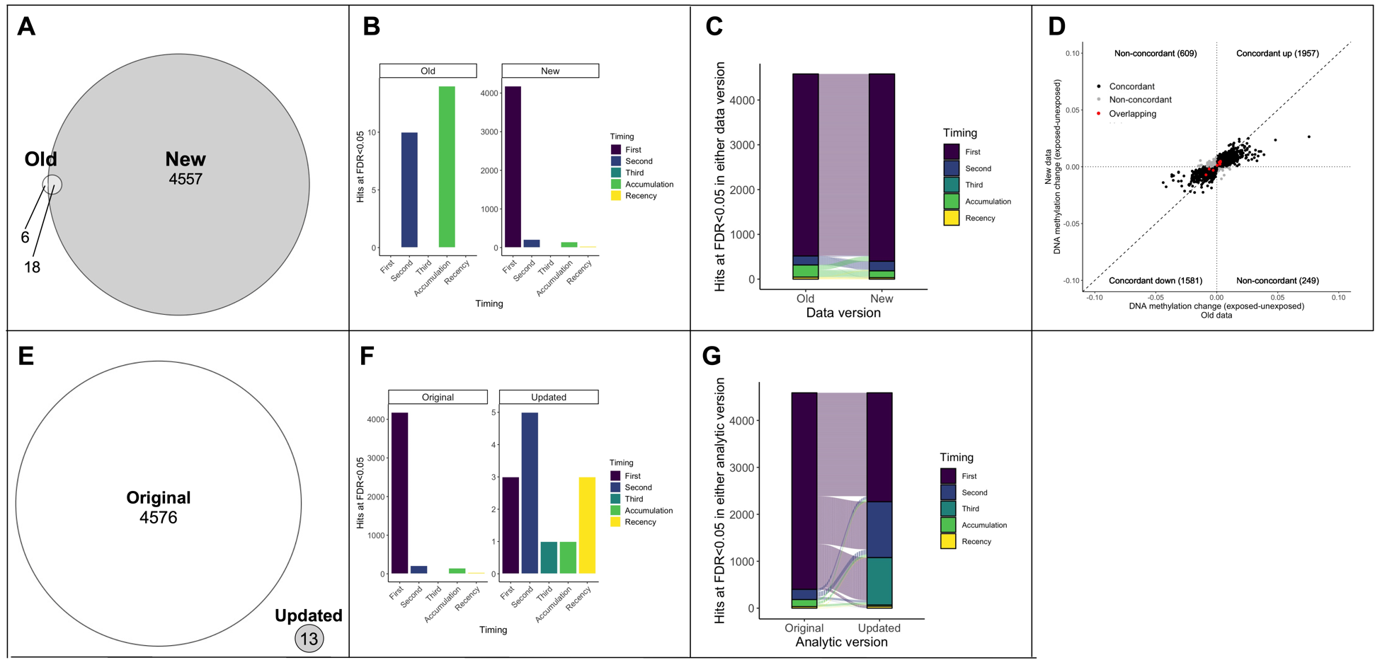
Figure S6. Results from the SLCMA of prenatal smoking.
A) Overlap of the hits at FDR<0.05 for the SLCMA of prenatal smoking between the old and new data.
B) The hypotheses selected most frequently across SLCMA hits were different between data versions (note that the scales are different between the panels of B).
C) The selected hypothesis of all top hits from E were generally consistent across analyses. Here, each line is a given CpG and shows how its selected hypothesis changes between analyses.
D) The change in DNAm between exposed and unexposed individuals across all top SLCMA hits from E was consistent between data versions, regardless of significance (r = 0.788; red = overlapping CpGs from A).
E) Overlap of the hits at FDR<0.05 for the SLCMA of prenatal smoking between the standard and updated analytic versions (new data).
F) Different patterns of hypothesis selected were present across both analytic versions (note that the scales are different between the panels of F).
G) The hypothesis selected across all significant CpGs from E was generally different across analytic versions.

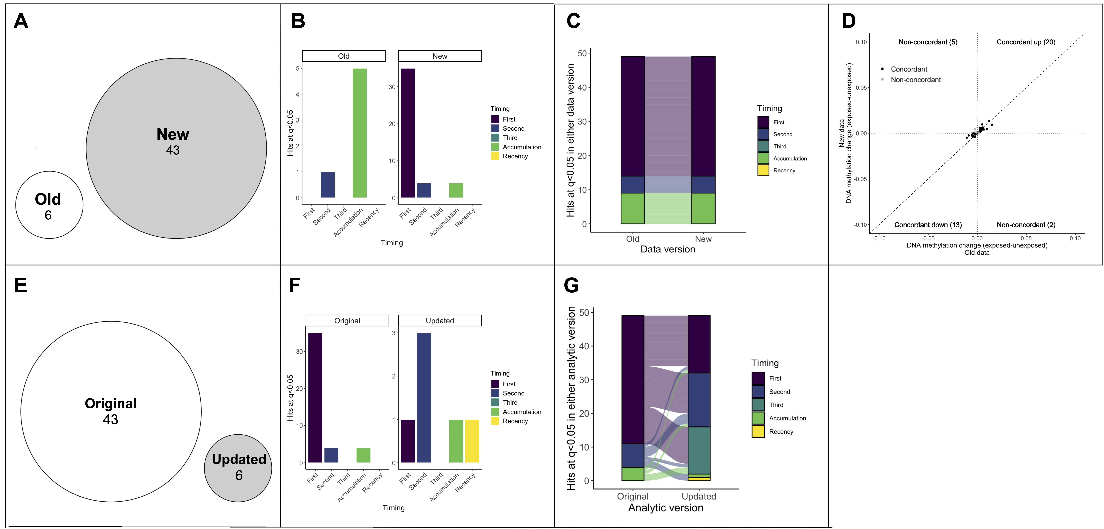
Figure S7. Bonferroni-corrected results from the SLCMA of smoking.
A) Overlap of the hits at a Bonferroni-corrected q<0.05 for the SLCMA of prenatal smoking between the old and new data.
B) The hypotheses selected most frequently across SLCMA hits were different between data versions (note that the scales are different between the panels of B).
C) The selected hypothesis of all top hits from E were generally consistent across analyses. Here, each line is a given CpG and shows how its selected hypothesis changes between analyses.
D) The change in DNAm between exposed and unexposed individuals across all top SLCMA hits from A was generally consistent between data versions, regardless of significance (r = 0.856).
E) Overlap of the hits at a Bonferroni-corrected q<0.05 for the SLCMA of prenatal smoking between the standard and updated analytic versions (new data).
F) Different patterns of hypothesis selected were present across both analytic versions (note that the scales are different between the panels of F).
G) The hypothesis selected across all significant CpGs from E was generally different across analytic versions.

