Supplemental Materials

Blood-brain correlations
We performed correlation analyses between DNAm levels in blood and brain at the 530 CpG sites included in the current study, annotated to the promoter regions of the sensitive period-regulating genes. The strength of blood-brain correlations was comparable across the three gene sets, with the average correlation being slightly higher in the expression gene set. Further, results from IMAGE-CpG (http://han-lab.org/methylation/default/imageCpG), a web-based application for interrogations of DNAm levels in the human brain and peripheral tissues (Braun et al., 2019), suggested 64% of the analyzed CpGs had positive blood-brain correlations, with 7.8% showing strong correlations (Spearman’s ρ ≥ 0.6), spanning 28 out of the 58 genes examined the current study (Figure S5).

Power analysis
To understand the statistical power of these analyses, we performed post hoc simulation-based power calculations of the linear discriminant analysis (LDA). In brief, because LDA can be considered equivalent to canonical correlation analysis (CCA; Bach and Jordan, n.d.), we used a recently-developed software tool (created after our analysis began), gemmr, to generate multivariate correlated data for CCA (Helmer et al., 2021). Prior studies suggest statistical power and stability of CCA-type analyses depend heavily on the number of samples per feature, with recommended numbers ranging between 10 and 70 (Barcikowski and Stevens, 1975; Helmer et al., 2021). In our analyses, the number of samples per feature was approximately 10 for the closing gene set, 25 for the opening gene set, and 44 for the expression gene set.
We performed simulations separately for each gene set. Data were generated with the same number of observations as our analytic sample (n=785) and the number of features was set to correspond to the actual number in each gene set. We varied the canonical correlation from 0.1 to 0.5, corresponding to a wide range of effect sizes. The prevalence of exposure was set to range from 5% to 25%, consistent with the observed time-varying prevalence across adversity in our study.
As shown in Figure S4, the estimated statistical power decreased when the gene set size increased and when the exposure prevalence decreased. Estimated power was the lowest for the closing gene set analysis, given the highest number of genes in that pathway. For an analysis to achieve at least 80% power to detect an effect comparable to the magnitude observed in our analyses (a canonical R² around 0.09), the exposure prevalence would need to be 10% or above for the opening gene set, 20% or above for the closing gene set, and at least between 5% and 10% for the expression gene set. For an exposure present in only 5% of the sample, the canonical R² would need to be approximately 0.15 or above for the analysis to be sufficiently powered.
References
Bach, F.R., Jordan, M.I., n.d. A Probabilistic Interpretation of Canonical Correlation Analysis 11.
Barcikowski, R.S., Stevens, J.P., 1975. A Monte Carlo Study of the Stability of Canonical Correlations, Canonical Weights and Canonical Variate-Variable Correlations. Multivariate Behavioral Research 10, 353–364. https://doi.org/10.1207/s15327906mbr1003_8
Braun, P.R., Han, S., Hing, B., Nagahama, Y., Gaul, L.N., Heinzman, J.T., Grossbach, A.J., Close, L., Dlouhy, B.J., Howard, M.A., Kawasaki, H., Potash, J.B., Shinozaki, G., 2019. Genome-wide DNA methylation comparison between live human brain and peripheral tissues within individuals. Translational Psychiatry 9, 47. https://doi.org/10.1038/s41398-019-0376-y
Helmer, M., Warrington, S., Mohammadi-Nejad, A.-R., Ji, J.L., Howell, A., Rosand, B., Anticevic, A., Sotiropoulos, S.N., Murray, J.D., 2021. On stability of Canonical Correlation Analysis and Partial Least Squares with application to brain-behavior associations. bioRxiv. https://doi.org/10.1101/2020.08.25.265546

Supplementary Tables

Table S1. Full list of CpG sites included in the current study (n=530) and their identified EWAS catalog entries.

The table has been included as an excel spreadsheet. Please see the file attached.
Table S2. Associations between time-dependent exposure to childhood adversity and DNA methylation in gene body regions of three gene sets known to regulate sensitive period functioning in the brain.
Childhood adversity | Sensitive period selected | Canonical R² | Wilks' lambda | Wilks' p-value | Bootstrap  p-value
Opening genes
Family instability | Very early childhood (0-2 years) | 0.04 | 0.96 | 0.206 | 0.508
Caregiver physical or emotional abuse | Early childhood (3-5 years) | 0.05 | 0.95 | 0.045 | 0.127
Maternal psychopathology | Early childhood (3-5 years) | 0.04 | 0.96 | 0.141 | 0.340
Sexual or physical abuse | Middle childhood (6-7 years) | 0.05 | 0.95 | 0.075 | 0.216
Financial hardship | Middle childhood (6-7 years) | 0.04 | 0.96 | 0.293 | 0.608
One adult in the household | Middle childhood (6-7 years) | 0.03 | 0.97 | 0.735 | 0.960
Neighborhood disadvantage | Middle childhood (6-7 years) | 0.05 | 0.95 | 0.105 | 0.257
Closing genes
Sexual or physical abuse | Very early childhood (0-2 years) | 0.10 | 0.90 | 0.211 | 0.522
Neighborhood disadvantage | Very early childhood (0-2 years) | 0.09 | 0.91 | 0.456 | 0.781
Caregiver physical or emotional abuse | Early childhood (3-5 years) | 0.10 | 0.90 | 0.303 | 0.629
Financial hardship | Middle childhood (6-7 years) | 0.11 | 0.89 | 0.190 | 0.449
One adult in the household | Middle childhood (6-7 years) | 0.10 | 0.90 | 0.345 | 0.658
Family instability | Middle childhood (6-7 years) | 0.11 | 0.89 | 0.164 | 0.430
Maternal psychopathology | Middle childhood (6-7 years) | 0.11 | 0.89 | 0.143 | 0.347
Expression genes
One adult in the household | Very early childhood (0-2 years) | 0.03 | 0.97 | 0.277 | 0.559
Neighborhood disadvantage | Very early childhood (0-2 years) | 0.03 | 0.97 | 0.312 | 0.625
Maternal psychopathology | Early childhood (3-5 years) | 0.03 | 0.97 | 0.249 | 0.535
Sexual or physical abuse | Middle childhood (6-7 years) | 0.03 | 0.97 | 0.127 | 0.331
Financial hardship | Middle childhood (6-7 years) | 0.03 | 0.97 | 0.397 | 0.747
Family instability | Middle childhood (6-7 years) | 0.03 | 0.97 | 0.104 | 0.286
Caregiver physical or emotional abuse | Middle childhood (6-7 years) | 0.04 | 0.96 | 0.032 | 0.098
Bootstrap p-values accounted for the number of hypotheses tested per gene set and adversity (i.e., three sensitive periods). No association corresponded to a bootstrap p-value under 0.05.

Table S3. Associations between any exposure to each type of childhood adversity before age 7 and DNA methylation in promoter regions of three gene sets regulating sensitive period functioning.
Childhood adversity | Canonical R² | Wilks' lambda | Wilks' p-value
Opening genes
Sexual or physical abuse | 0.06 | 0.94 | 0.041
Financial hardship | 0.04 | 0.96 | 0.658
One adult in the household | 0.03 | 0.97 | 0.882
Family instability | 0.03 | 0.97 | 0.881
Neighborhood disadvantage | 0.04 | 0.96 | 0.532
Caregiver physical or emotional abuse | 0.03 | 0.97 | 0.755
Maternal psychopathology | 0.05 | 0.95 | 0.286
Closing genes
Sexual or physical abuse | 0.11 | 0.89 | 0.212
Financial hardship | 0.08 | 0.92 | 0.867
One adult in the household | 0.09 | 0.91 | 0.549
Family instability | 0.11 | 0.89 | 0.209
Neighborhood disadvantage | 0.07 | 0.93 | 0.879
Caregiver physical or emotional abuse | 0.08 | 0.92 | 0.771
Maternal psychopathology | 0.10 | 0.90 | 0.202
Expression genes
Sexual or physical abuse | 0.01 | 0.99 | 0.851
Financial hardship | 0.03 | 0.97 | 0.243
One adult in the household | 0.02 | 0.98 | 0.707
Family instability | 0.03 | 0.97 | 0.258
Neighborhood disadvantage | 0.02 | 0.98 | 0.554
Caregiver physical or emotional abuse | 0.01 | 0.99 | 0.886
Maternal psychopathology | 0.02 | 0.98 | 0.784
Because only one hypothesis was tested for each type of adversity, no bootstrapping was performed.
Bolded value indicated associations with p<0.05.

Table S4. Associations between presence versus absence of exposure to any of the seven types of adversity during each time period and DNA methylation in promoter regions of three gene sets regulating sensitive period functioning.
Gene set | Sensitive period selected | Canonical R² | Wilks' lambda | Wilks' p-value
Opening | Middle childhood (6-7 years) | 0.06 | 0.94 | 0.229
Closing | Middle childhood (6-7 years) | 0.12 | 0.88 | 0.294
Expression | Very early childhood (0-2 years) | 0.03 | 0.97 | 0.173
At each time period, an individual was coded as exposed if they were exposed to any type of childhood adversity.

Table S5. CpG-level results of loci with FDR q-value < 0.2 located in promoters of sensitive period genes, using the structured life course modeling approach (SLCMA) performed by Lussier et al. (2020).
Gene set | Gene name | CpG | SLCMA p-value | Adversity | Selected hypothesis | FDR  q-valueª | R²
expression | KCNK2 | cg11346522 | 1.78E-04 | Neighborhood disadvantage | Very early childhood  (1.75 years) | 0.094 | 0.022
closing | MMP3 | cg16466334 | 4.03E-04 | Family instability | Early childhood  (4.75 years) | 0.148 | 0.020
expression | GRIN2A | cg06922606 | 6.24E-04 | Family instability | Middle childhood  (6.75 years) | 0.148 | 0.018
closing | MBP | cg26457248 | 8.38E-04 | Family instability | Early childhood  (4.75 years) | 0.148 | 0.018
ª FDR corrections were applied to correct for looking up results at 530 CpG sites. Lussier et al. assessed associations between time-varying exposures to the same seven types of childhood adversity as the current study and genome-wide DNA methylation (DNAm) at 440,257 CpG sites using the SLCMA, which simultaneously compares competing hypotheses for the mechanisms of exposures.

Supplementary Figures

Figure S1. Prevalence of exposure to childhood adversity at each developmental time period before age 7 in the analytic sample (n=785).
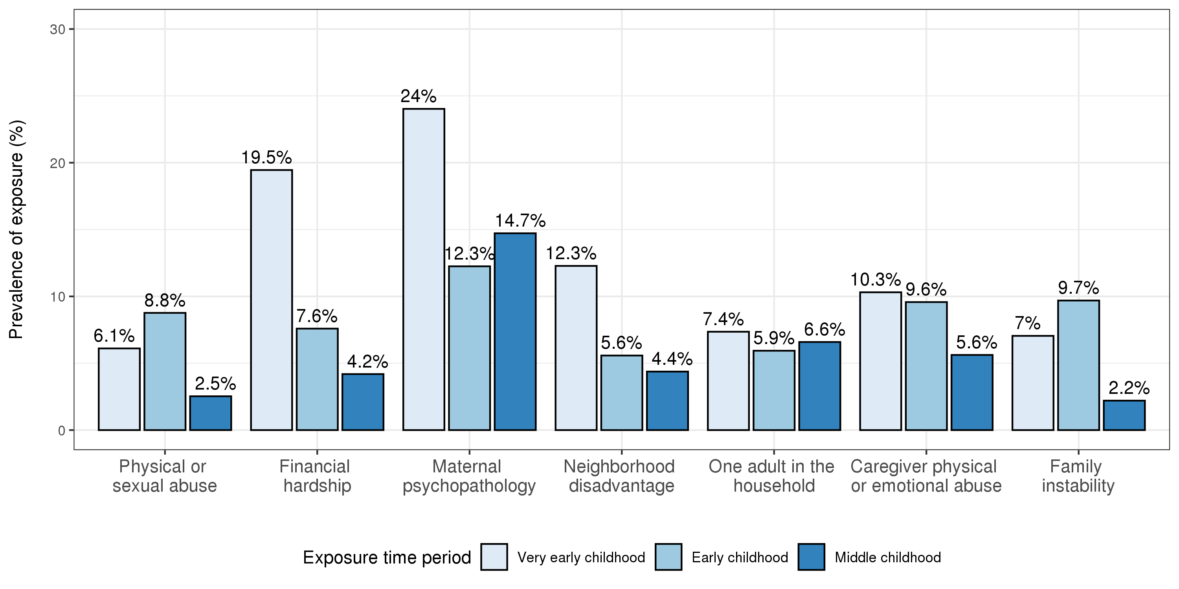

Figure S2. Tetrachoric correlations between exposures at different time periods within each type of childhood adversity before age 7 in the analytic sample (n=785). Time periods considered: very early childhood (0-2 years); early childhood (3-5 years); middle childhood (6-7 years).

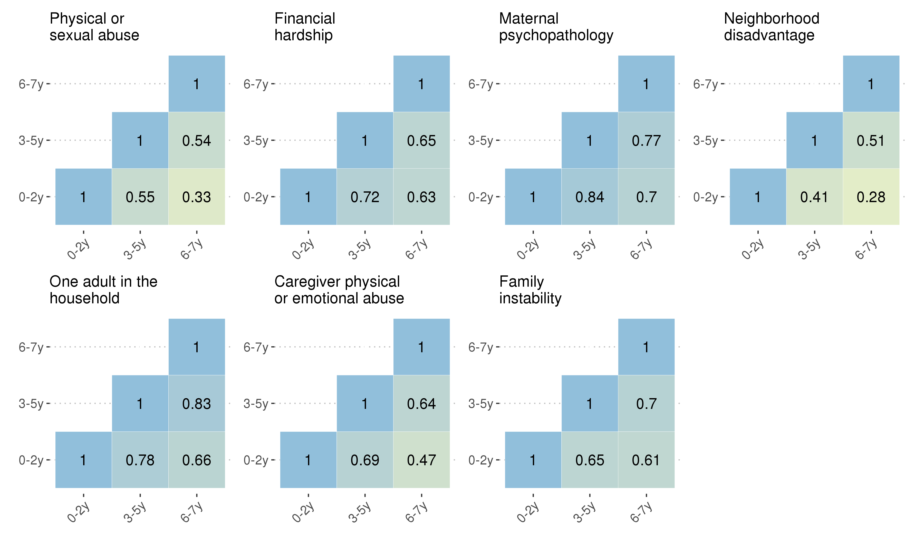

Figure S3. Tetrachoric correlations between exposures between different types of childhood adversity before age 7 within each time period in the analytic sample (n=785). Time periods considered: very early childhood (0-2 years); early childhood (3-5 years); middle childhood (6-7 years).

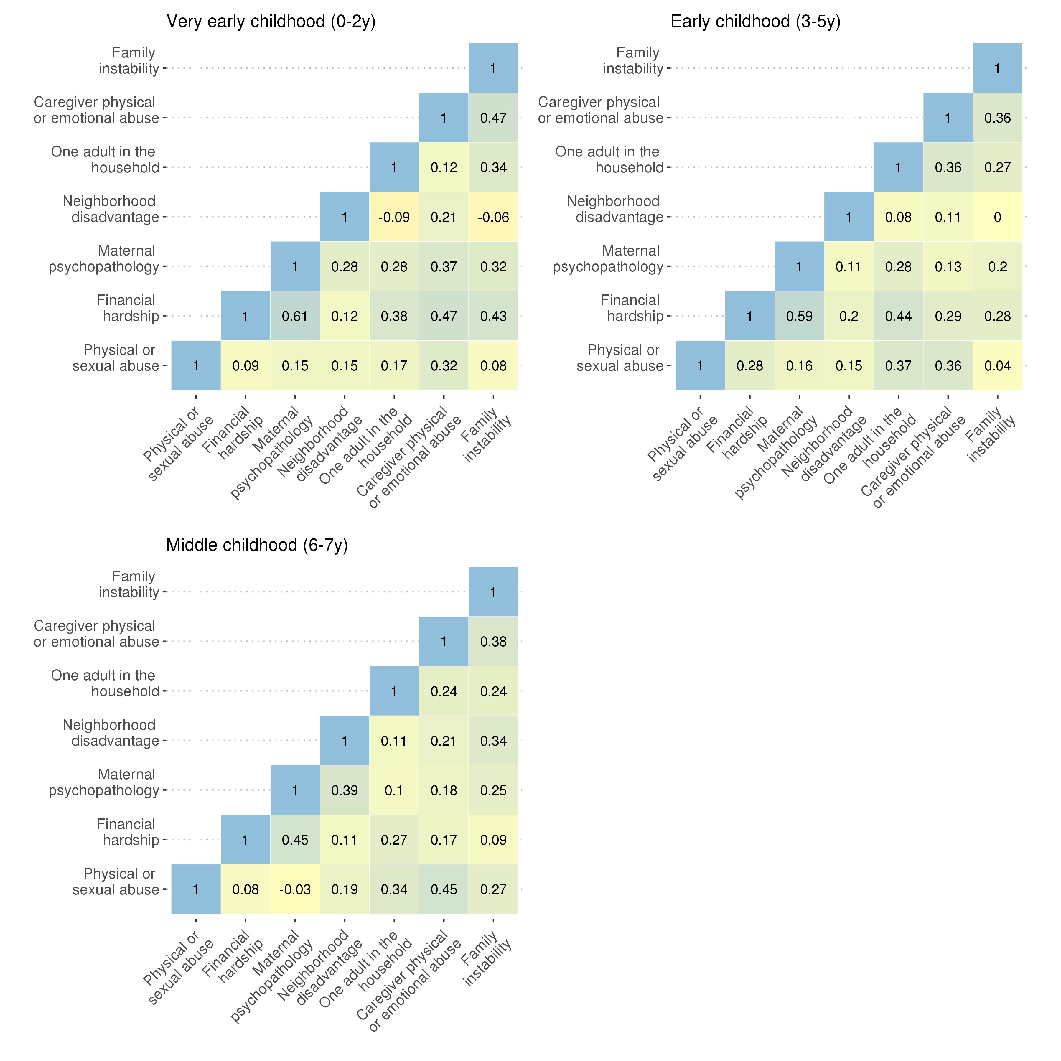

Figure S4. Simulation-based power analysis. Purple horizontal dotted line indicates 80% statistical power. Brown vertical dotted indicates a correlation of 0.3, or a canonical R² of 0.09, which was comparable to effects observed in our analyses.
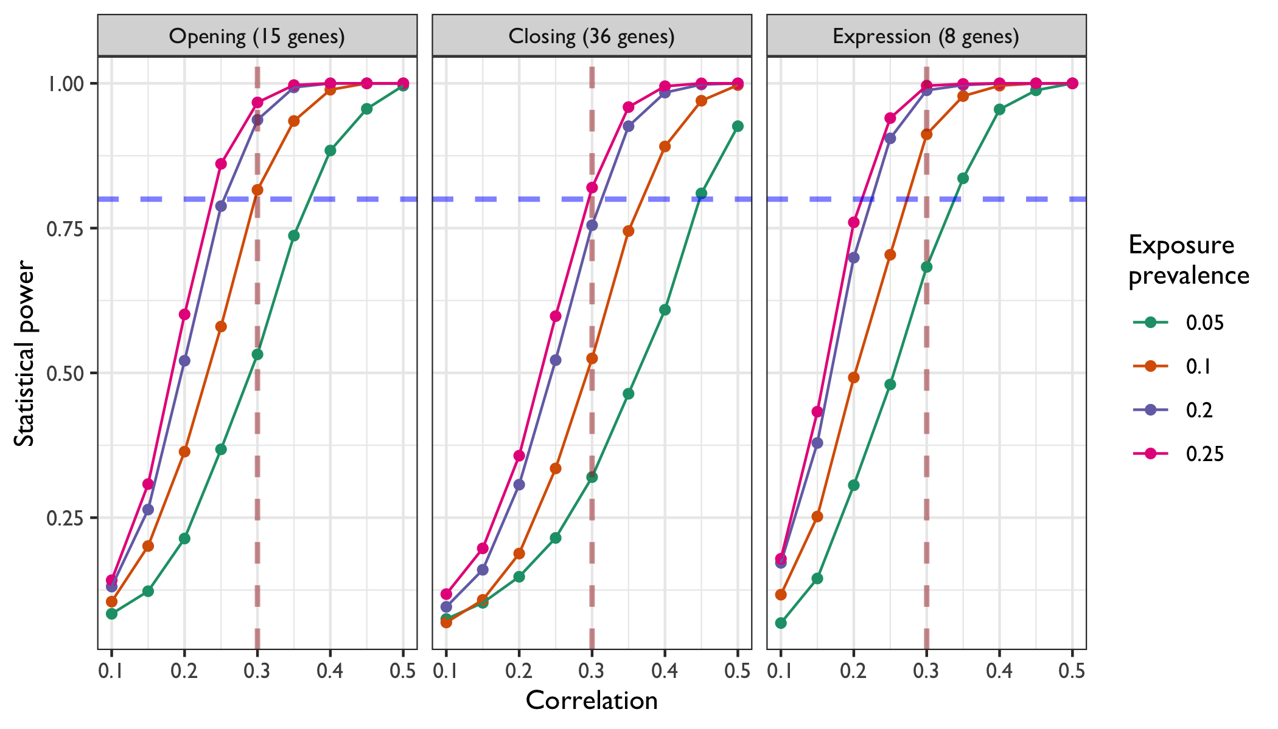

Figure S5. Correlation coefficient distributions for DNA methylation between brain and blood tissues for CpGs in promoters of sensitive period genes (data from Braun et al., 2019).

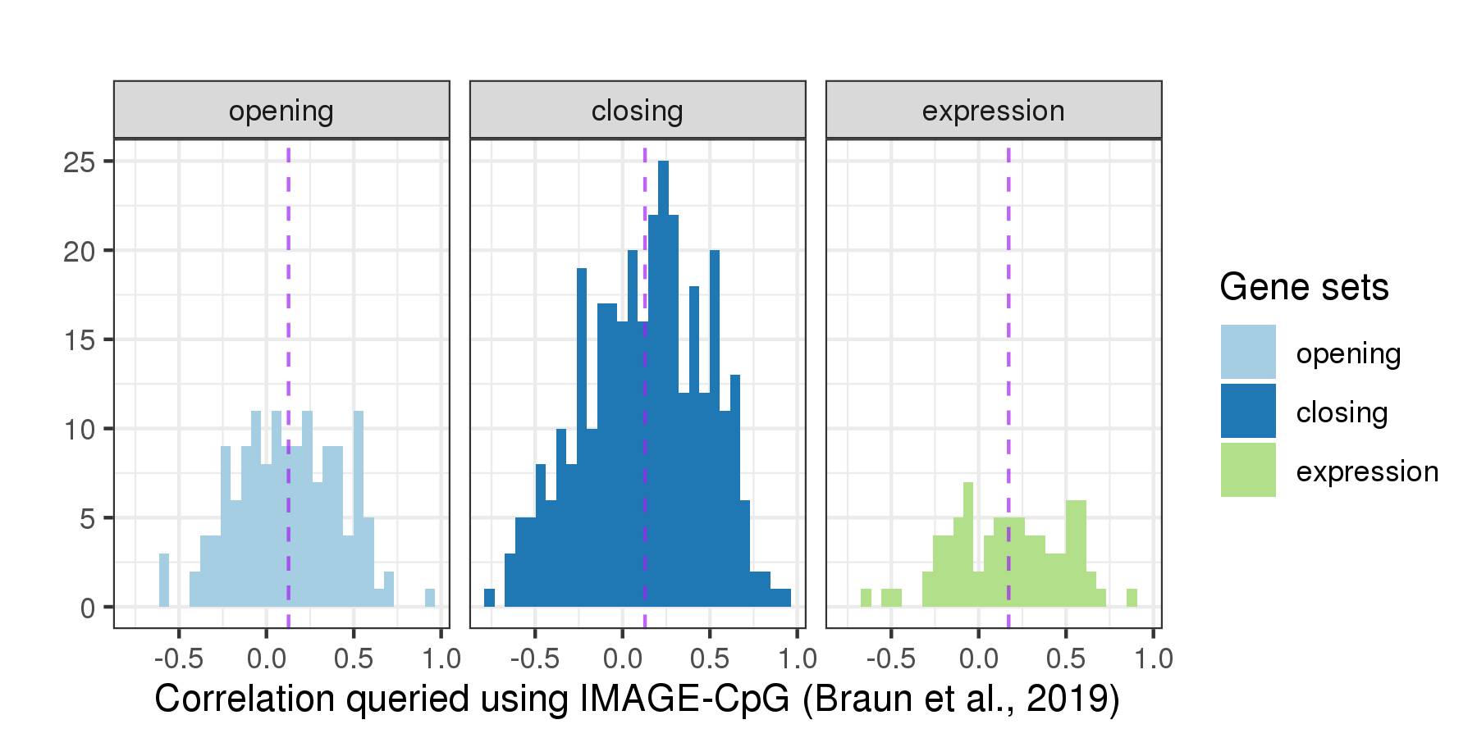
Note. A total of 527 CpGs are shown in the plot, annotated to 58 unique genes. The average correlation coefficients corresponding to CpGs in each gene set are: r=0.13 for opening genes; r=0.13 for closing genes; r=0.17 for expression genes, as indicated by the purple dashed lines.

